Flow Betweenness

Method

Flow Betweenness is the method of calculating the betweenness centrality of each vertex. It can be applied by the function of “flowbet” from the package of “sna” in R. The function is calculated based on the formula of
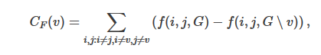
In our project, we calculate the flow betweenness based on the positions. When the flow betweenness of the position goes higher, it means there are more passes coming in and going out from the position. Since we already find the most important position in both teams by the degree centrality and the graph, We can see if the flow betweenness of the most important position has a relationship with the Game winning.

Result
We are going to see the flow betweenness of the Lakers first. A line graph is made based on the positions for each team, where X-axis is the Game points and Y-axis stands for the flow betweenness. The line with points is the most important position in the team, which indicates the shooting guard in Lakers. It is reasonable because Kobe is considered as the superstar of Lakers.
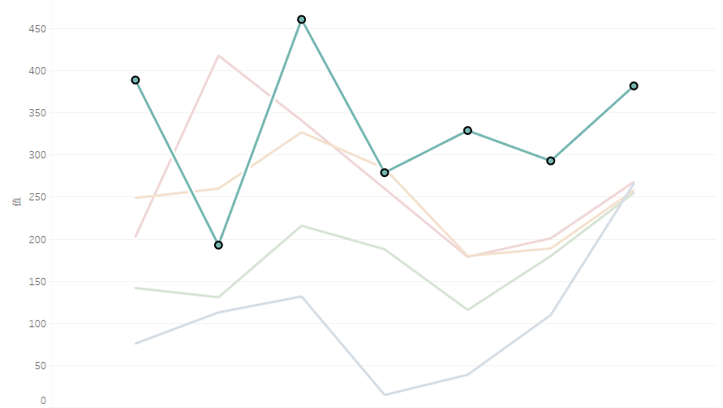
Lakers won the Game 1, Game 3, Game 6 and Game 7. Comparing to the reality of the Games, it has the positive ratio of passes and Game winning. Due to the fact that Kobe is the most important shooter in Lakers, there are more chances that other people are shooting if he passes more. Therefore it could relieve Kobe’s pressure and they play more like a team.
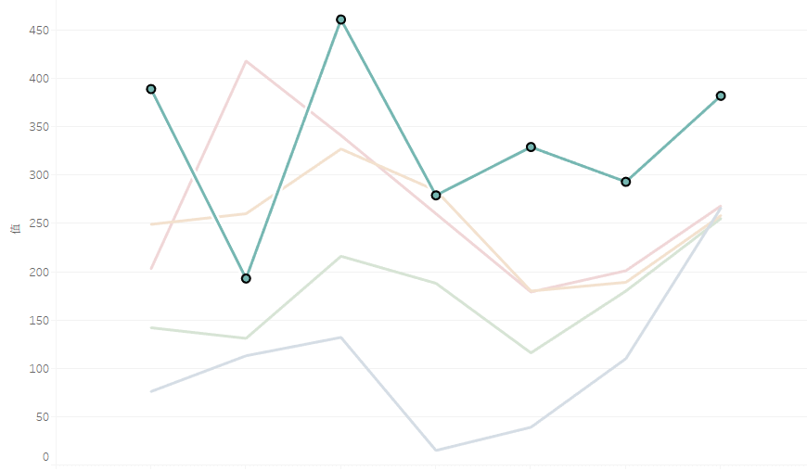

Here is the graph of Celtics. We point out the Point Guard as the most important position. Rondo is the ball handler of the Celtics and his main responsibility is to pass the ball to the right position at the right time. While in the graph shows above, if the flow betweenness of Rondo is lower, Celtics is more likely to win the game. It is also reasonable because when there are less passes through Rondo, there are more chances of other people handling the ball, which indicates they play more like a team than individuals.

